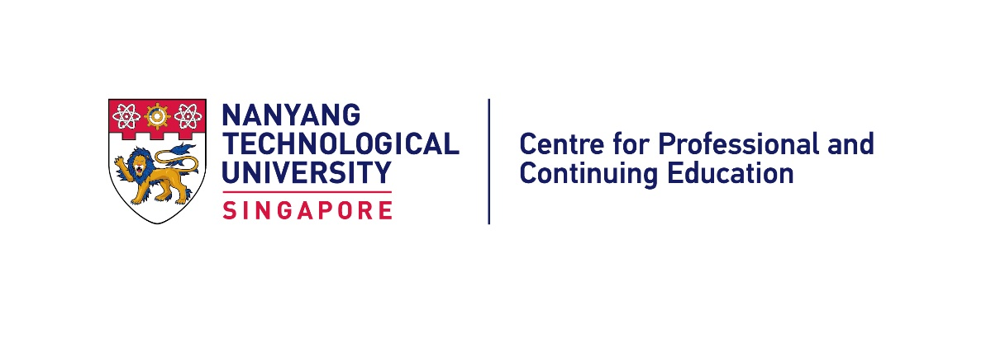

**AI & GPT**

**29 Jan to 2 Feb 2024**

**Venue: Nanyang Technological University**

**63 Nanyang Drive, Singapore 636922**

**NTU Learning Hub North, The Arc**

**Lecturer: Dr Teoh Teik Toe**

**Programme Schedule**

|  |  |  |
| --- | --- | --- |
| **Date/Day** | **Time** | **Programme** |
| 29 Jan 2024  Monday | 09:30 – 09:45  09:45 – 12:30  TR+21, Level 1  (LHN-L1-09) | **Opening Remarks and Welcome  by Dr Teoh Teik Toe**  **Session 1:**  **Introduction to Chatbots** |
| 30 Jan 2024  Tuesday | 14:00 – 16:30  TR+21, Level 1  (LHN-L1-09) | **Session 2:**  **Role of Artificial Intelligence** |
| 31 Jan 2024  Wednesday | 09:30 – 12:00  TR+03, B2  (LHN-B2-03) | **Session 3:**  **Objectives of AI** |
| 1 Feb 2024  Thursday | 09:30 – 12:00  TR+02, B2  (LHN-B2-02) | **Session 4:**  **Convergence & Future Outlook** |
| 2 Feb 2024  Friday | 14:00 – 16:30  TR+02, B2  (LHN-B2-02) | **Session 5:**  **Group Presentation by Participants**  **Closing Ceremony**  Certificate Presentation and Group Photography  Attire: Blazer and uniform |

*\* Programme schedule may subject to change.*